**Session-7**

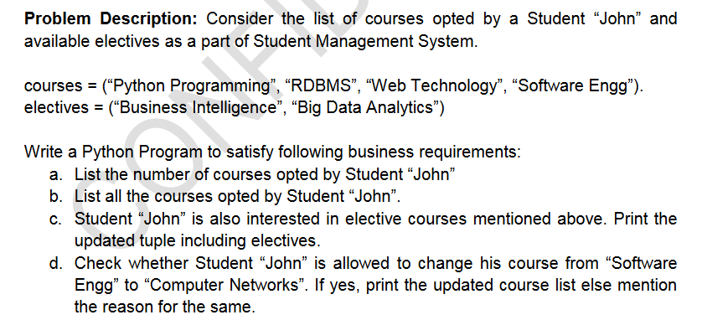

**Q2**



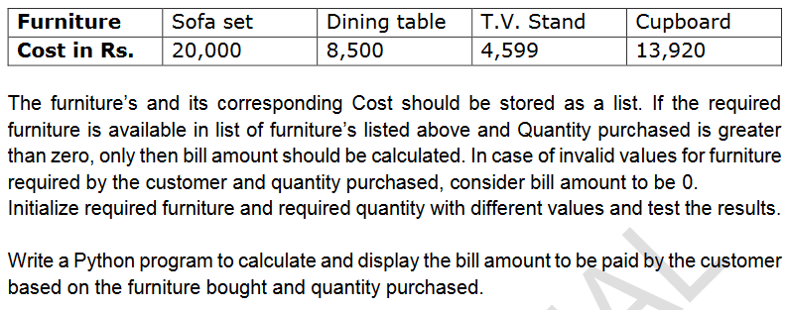

**Q3**

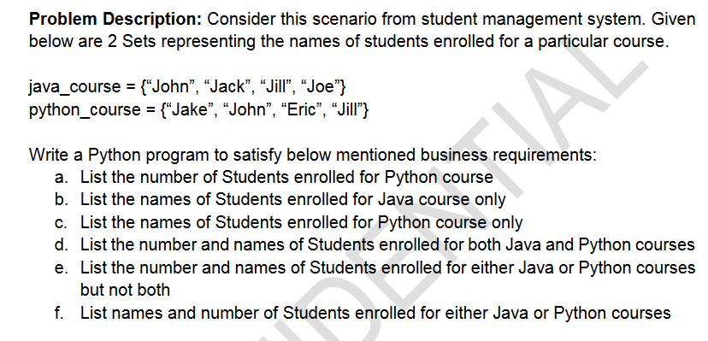

**Q4**

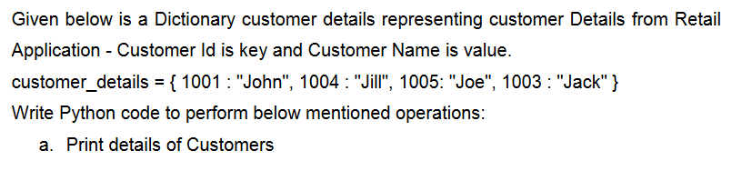

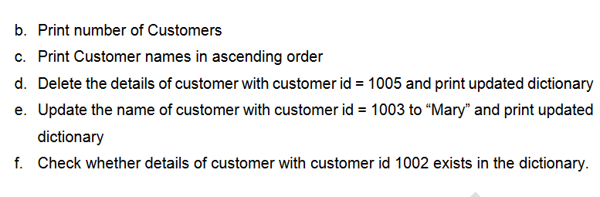

1. **Write a python program to generate Fibonacci series up to ‘n’ terms store it in list and display.**
2. **Implement a stack using list**
3. **Implement a queue using list**
4. **Cate Hospital wants to know the medical specialty visited by the maximum number of patients. Assume that the Patient id of the patient along with the medical specialty visited by the patient is stored in a list. The details of the medical specialties are stored in a dictionary as follows:**

**{**

**“P”:”Pediatrics”,**

**“O”:”Orthopedics”,**

**“E”:”ENT”**

**}**

**Write a function to find the medical specialty visited by the maximum number of patients and return the name of the specialty.**

**Note: Assume that there is always only one medical specialty which is visited by maximum number of patients.**

**Sample Input Expected Output**

**[ 101, P, 102, O, 302, P, 305, P] Pediatrics**

**[ 101, O, 102, O, 302, P, 305, E, 401, O,656, O] Orthopedics**

**[ 101, P, 102, E, 302, P, 305, P, 401, E, 656, O, 987, E] ENT**

**Estimated Time: 40 Minutes**

1. **The Road Transport Corporation(RTC) of a city wants to know whether a particular bus- route is running on profit or loss. Assume that the following information is given:**

* **Price per Litre of fuel = 70**
* **Mileage of the bus in km/litre of fuel = 10**
* **Price (Rs) per Ticket = 80**

**The bus runs on multiple routes having different distance in kms and number of passengers.**

**Write a Python program to calculate and return the profit earned(Rs) in each route. Return -1 in case of loss.**

1. **Write a python program to find all the Strong numbers among the given list of numbers. Write a function to find and return the factorial of a number. Use it to solve the problem.**

**Example of Strong number:**

**N=145=1!+4!+5!=1+24+120=145**

**Hint: Sample list can be[145, 375, 100, 2, 10]**

1. **Write a python program to display all the duplicate values in a list.**

**Example :**

**Sample Input: [12, 54, 68, 759, 24, 15, 12, 68, 987, 758, 25, 69]**

**Expected Output: [12, 68]**

**Estimated Time: 40 Minutes**

1. **Given a list Integer vale, write a python program to check whether it contains same number in subsequent position. Display the count of such occurrences.**

**Estimated Time: 30 Minutes**

**Sample Input Sample Output**

**[1, 1, 5, 100, 20, 20, 6, 0, 0] 3**

**[10, 20, 30, 40, 30, 20] 0**

**[1, 2, 2, 3, 4, 4,10] 2**

1. **The Metro Bank provides various types of loan such as car loans, Business loans and house loans to its account holders. Write a python program to implement the following requirements:**

* **Initialize the following variables with appropriate input values: Account_Number, Account_balance, salary, loan_type, Loan_amount_expected and Customer_emi_Expected.**
* **The Account number should be of 4 digits and its first digit should be 1.**
* **The customer should have a minimum balance of Rupees 1 lakh in the account.**
* **If the above rules are valid, determine the eligible loan amount and the EMI that the bank can provide to its customer based on their salary and the loan type they expect to avail.**
* **The bank would provide the loan, only if the loan amount and the number of EMI’s requested by the customer is less than or equal to the loan amount and the number of EMI’s decided by the bank respectively.**

**Display appropriate error message for the invalid data. If all the business rules are satisfied, the display account number, eligble and requested loan amount and EMI’s.**

**Test your code by providing different values for input variables.**

**Salary Loan Type Eligible loan amount No. of EMI’s Required to Repay**

**>25000 Car 500000 36**

**> 50000 House 6000000 60**

**> 75000 Business 7500000 84**

1. **Write a python program to find the bill amount to be paid by the customer while ordering food online from a restaurant. The bill amount includes the amount for the food ordered based on the quantity and delivery charge based on distance of delivery as mentioned below:**

**The Restaurant , home delivers the vegetarian combo costing Rs. 120 per plate and the non-vegetarian Rs. 150 per plate. Infact the restaurant gets more order for non- vegetarian combo than the vegetarian combo.**

**The Customer must specify the type of food, quantity (no. of paltes) required and the approximate distance in kms from the restaurant to the delivery point.**

**The below information must be use to check the validity of data provided by the customer:**

* **Type of food must be ‘V’ for vegetarian and ‘N’ for non-Vegetarian.**
* **Distance in kms must be greater than 0.**
* **Quantity ordered should be minimum 1**

**Identify the cost of food and delivery charge based on the type of food and distance provided. Then the bill amount must be calculated as give below:**

**Bill amount = cost per plate* quantity ordered+ Delivery charge**

**Use the information provided in the table below to calculte the delivery charge. The bill amount should be returned as -1, if any of the inputs is invalid**

**Distance in kms. Delivery charge in Rs per km.**

**For first 3 kms 0**

**For next 3 kms 3**

**For the remaining 6**

**Note: Initialize type of food, quantity and distance in kms with different values and test your program.**

1. **Harley was booking flight tickets for the vacation trip. The ticket rates mentioned were as follows for the round-trip:**

**Rate per Child : 1/3rd of the rate per adult**

**Service Tax: 7% of the ticket amount (including all passengers)**

**As it was a holiday season, the airline also offered 10% discount on the final ticket cost (after inclusion of the service tax).**

**Harley booked the tickets for 2 adults and 3 children. Find and display the total ticket cost of Harley.**

**Test the program with different input values for number of adults and children.**

1. **Write a python program to find and display the product of three positive integer values (taken as input in list) based on the rule mentioned below:**

**It should display the product of the three values except when one of the integer value is 7. In that case, 7 should not be included in the product and the values to its left also should not be included.**

**If there is only one value to be considered, display that value itself. If no values can be included in the product, display -1.**

**Note: Assume that if 7 is one of the positive integer values, then it will occur only once. Refer the sample I/O given below**

**Sample Input Expected Output**

**1, 5, 3 15**

**3, 7, 8 8**

**7, 4, 3 12**

**1, 5, 7 -1**

1. **Write a Python program which finds the maximum number from num1 to num2 (num2 inclusive) based on the following rules.:-**
2. **num1 should be less than num2**
3. **Consider each number from num1 & num2 and add number to list iff below conditions are satisfied: -**
   1. **Sum of digits of the number are multiple of 3**
   2. **Number has only two digits**
   3. **Number is multiple of 3**
4. **ARS gem store sells different variety of gems to customers. The dictionary of gems and its price[gems as key and price as value] are given below:-**

**Gem Emerald Ivory Jasper Ruby Garnet**

**Price in Rs. 1760 2119 1599 3920 3999**

**Write a python program to calculate and display the bill amount to be paid by the customer based on the list of gems(gem_list) and quantity purchased(qty_list). Quantity purchased must be greater than 0. The customers are also entitled for discount based on gems purchased. Refer the table below for discount provide. In case more than one discount is applicable, the total discount % should be applied on the total bill amount.**

**Gems Discount**

**Ivory 3%**

**Ruby 4%**

**Others 6%**

**In case of invalid values for any of quantity purchased or gems required display bill amount=-1.**

**Initialize required gem_list and qty_list containing names of gems to be purchased and required quantity of purchase for a customer and display the bill amount.**

1. **Consider the scenario of processing marks of students for a course in student management system . Given below is the list of marks scored by students. Find top three scorers for the course and also display average marks scored by all the students.**

